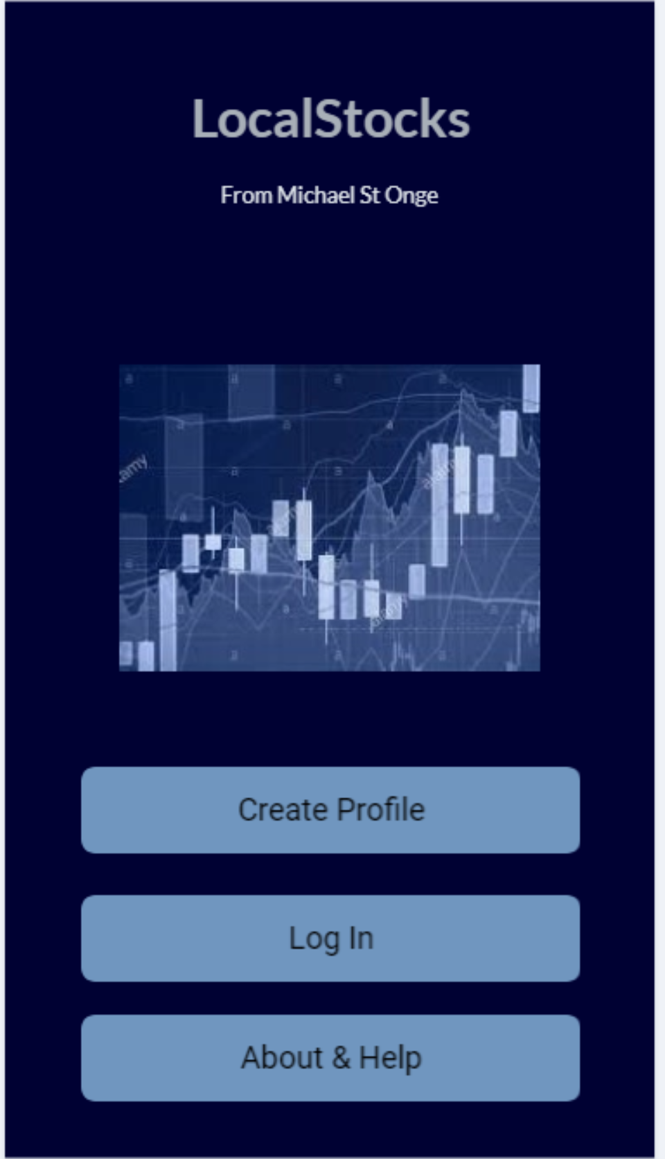

This is the introductory view controller the user sees when first opening the app. They are given the options of creating a profile or logging in. If the user has logged in recently, they will bypass the screen and go straight to their profile. There is also an about and help option which lets the user see legal information and information about what the app does.

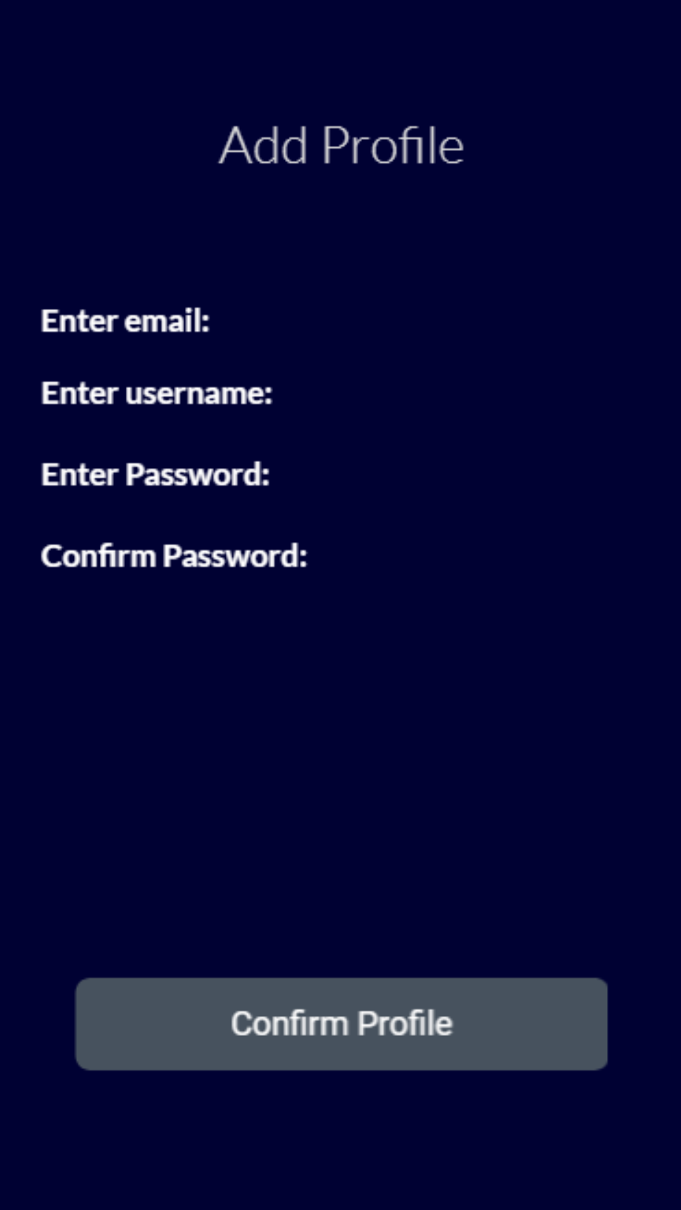

This screen allows the user to create a new profile. It requires the standard information: email, username, and password. This verifies that two accounts don’t both create a profile.

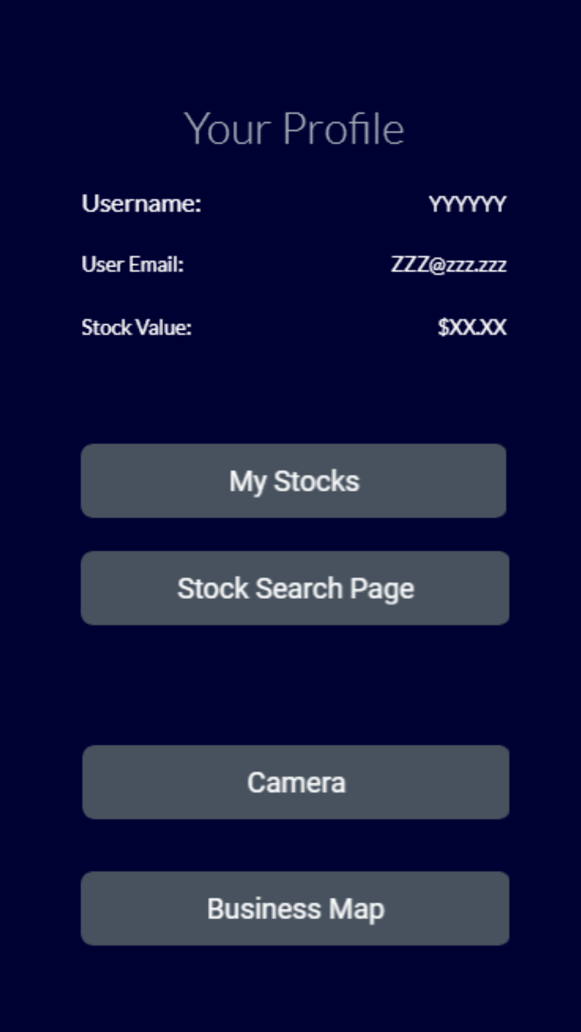

This page serves as the true home page for the application. From this screen the user is able to see their account information and the sum of the value of the stocks on their watchlist. The user can navigate to their watchlist through the My Stocks button, they can navigate to the search area through the stock search page. Additionally, the camera and map can also be accessed through this screen.

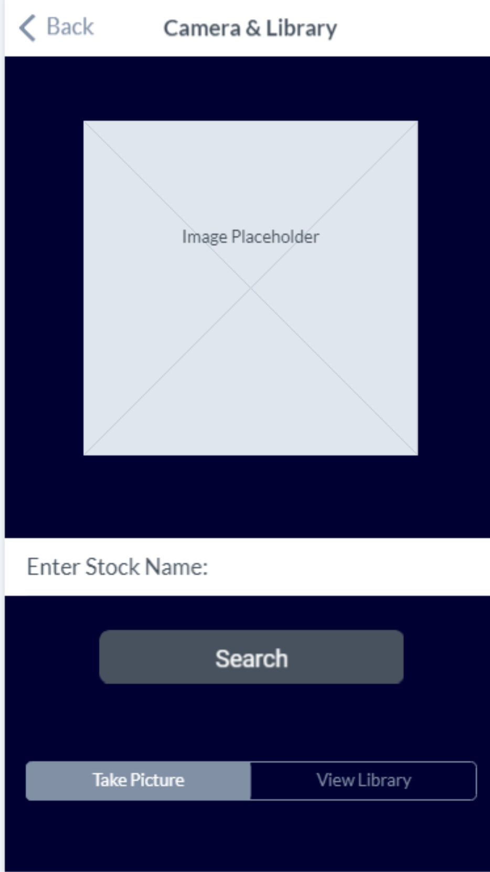

The camera allows the user to take pictures of businesses they might be interested in looking up later, in case they are offline. The user can also view previous pictures they might have taken to see if there are any businesses they might be interested in investing in. From the screen, the user can navigate to the stock search page to lookup a stock they are interested in or return to the My Profile page.

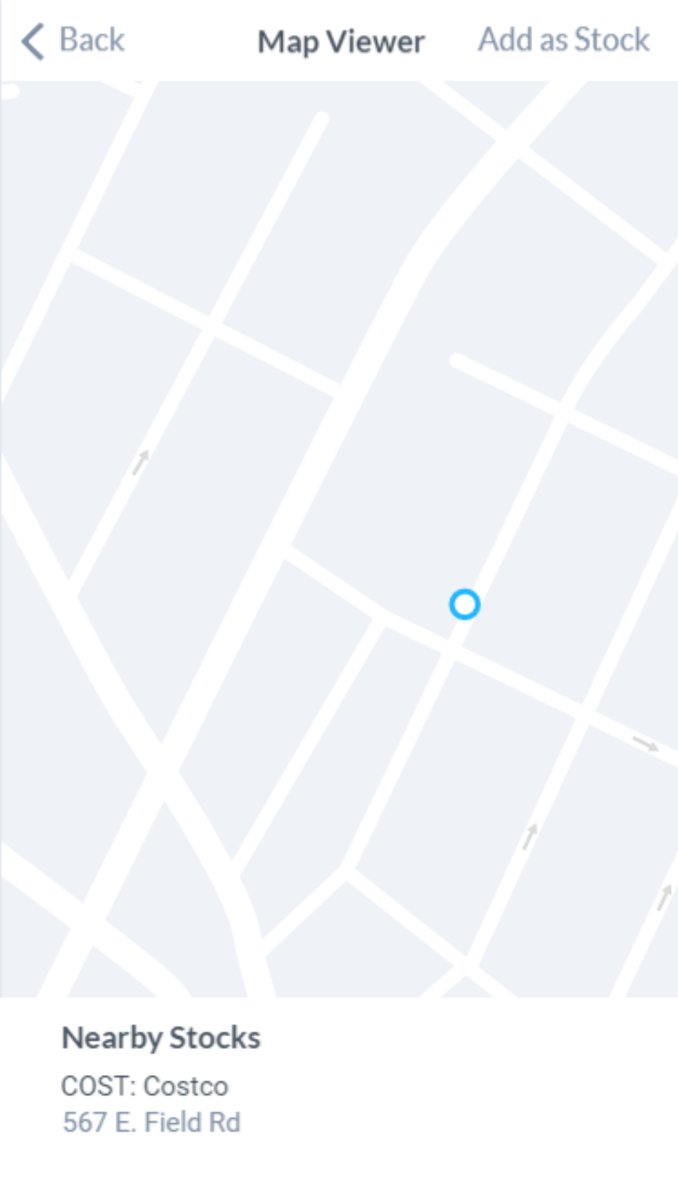

The mapViewController allows the user to find nearby companies in their area. If enabled, the map will navigate to the user’s location to see if there are businesses nearby them that they might be interested in. A search will automatically be performed when a company is selected to see if that company has a publicly offered stock. The user can add stocks directly to their watchlist from this screen for ease of access.

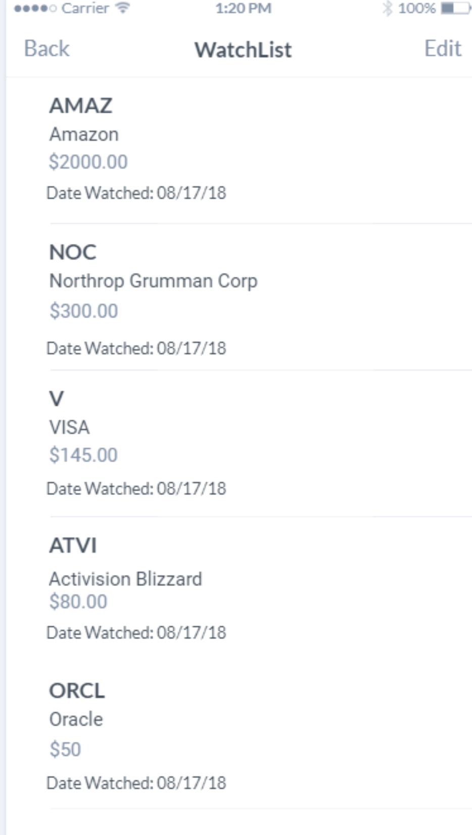

This page will allow the user to access all the stocks that they have added to their watchlist. It will display basic information such as ticker symbol, full name, price, and the date they started watching. The user will be able to trash stocks directly from this screen. The user can also navigate to the stocks page by selected one of the cells. This page’s functionality will be implemented by a table view.

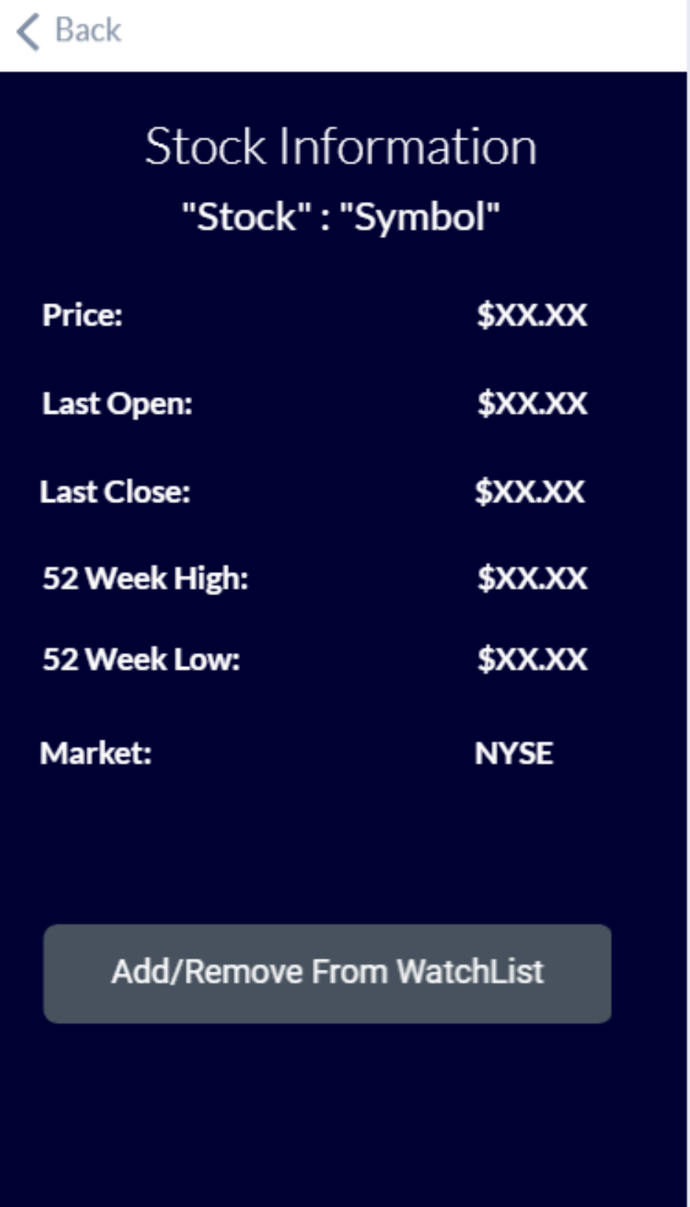

This is the main page for an individual stock. Depending on information I am able to get from an API, this screen will have more or less fields. This page displays information for a certain stock. From this screen, they can also add or remove a stock from their watch list. This page will unwind to the viewcontroller that called it.

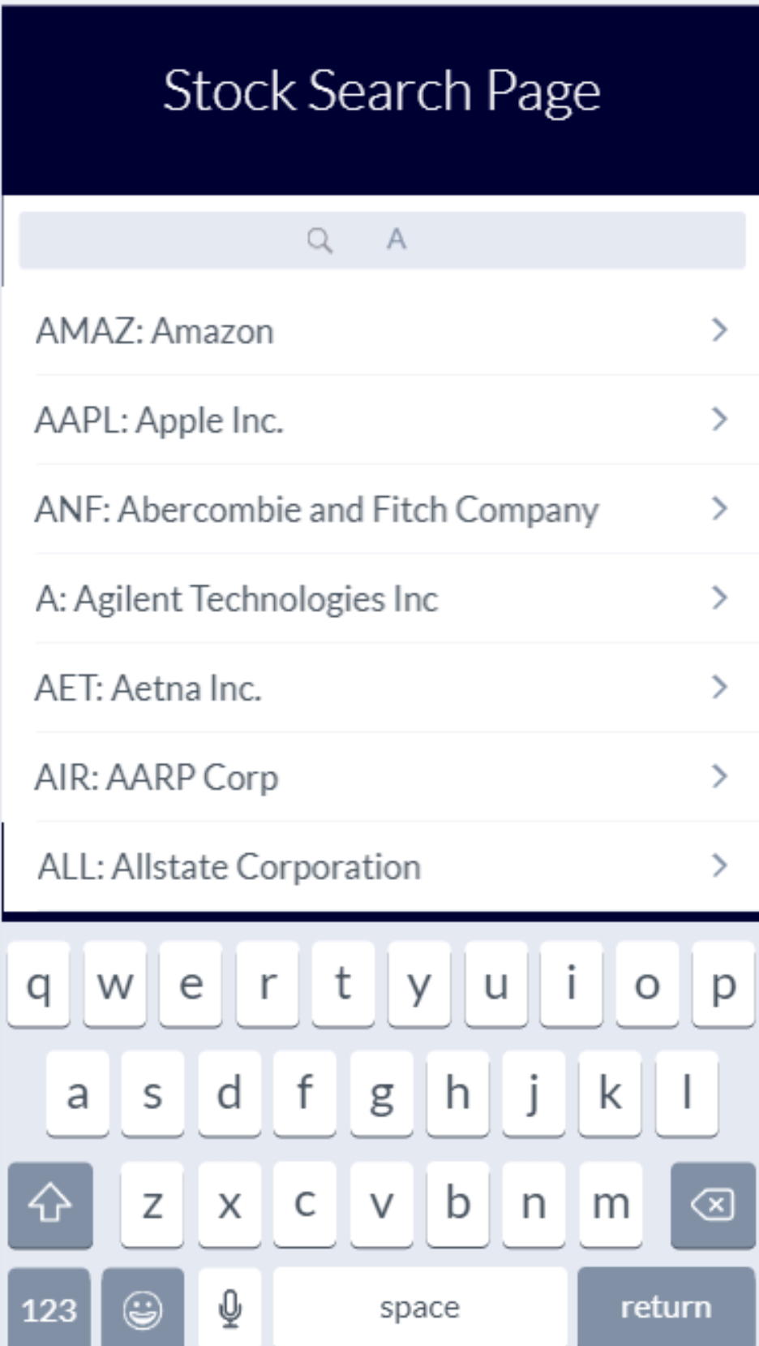

This page allows the user to search directly for stocks. From this screen, a search bar is implemented, which interfaces directly with the API. When a button is pressed, the screen will wait half a second for another press before searching. If another button is pressed, it will stop the search and restart it.